Chapter One

Introduction to Operating Systems
Introduction
Every computer must have an operating system to run other programs. The operating system coordinates the use of the hardware among the various system programs and application program for a various user. It simply provides an environment within which other programs can do useful work.
The operating system is a set of special programs that run on a computer system that allow it to work properly. It performs basic tasks such as recognizing input from the keyboard, keeping track of files and directories on the disk, sending output to the display screen and controlling a peripheral device.

What is an operating system?
An operating system has many definitions.
- An operating System (OS) is an intermediary between users and computer hardware.
- An operating system (OS) is a software program that manages the hardware and software resources of a computer. The OS performs basic tasks, such as controlling and allocating memory, prioritizing the processing of instructions, controlling input and output devices, facilitating networking, and managing files.
- The purpose of an operating system is to provide an environment in which a user can execute programs in a convenient and efficient manner.
- An operating System controls the allocation of resources and services such as memory, processors, devices and information.
- An operating system is a program that acts as an interface between the user and the computer hardware and controls the execution of all kinds of programs.

OS is designed to serve two basic purposes:
1. It controls the allocation and use of the computing system ‘s resources among the various user and tasks.
2. It provides an interface between the computer hardware and the programmer that simplifies and makes feasible for coding, creation, debugging of application programs.
The operating system must support the following tasks. The tasks are:
1. Provides the facilities to create, modification of program and data files using and editor.
2. Access to the compiler for translating the user program from high level language to machine language.
3. Provide a loader program to move the compiled program code to the computer ‘s memory for execution.
4. Provide routines that handle the details of I/O programming.
- A computer system basically has four components
  - Hardware – provides basic computing resources (CPU, memory, I/O devices).
  - Operating system – controls and coordinates the use of the hardware among the various application programs for the various users.
  - Applications programs – define the ways in which the system resources are used to solve the computing problems of the users (compilers, database systems, video games, business programs).
  - Users (people, machines, other computers).
- It's job include:
    - Process Management
A key concept in all OSs is the process. A program does nothing unless its instructions are executed by a CPU. A program in execution, as mentioned, is a process.
A process needs certain resources- including CPU time, memory, files, and I/O devices to accomplish its task. These resources are either given to the process when it is created or allocated to it while it is running.
- The OS is responsible for the following activities in connection with process management:
- Creating and deleting both user and system processes,
- Suspending and resuming processes,
- Providing mechanisms for process synchronization,
- Providing mechanisms for process communication,
- Providing mechanisms for deadlock handling.
    - Memory Management
In a very simple OS, only one program at a time is in the memory. To run second program, the first one has to be removed and the second one placed in memory. Single Tasking system.
More sophisticated Oss allow multiple programs to be in memory at the same time. To keep them from interfering with one another and some kind of protection mechanism is needed. Multi-Tasking system.
- The OS is responsible for the following activities in connection with memory management:
- Keeping track of which parts of memory are currently being used by whom,
- Deciding which processes (parts of thereof) and data to move into and out of memory,
- Allocating and de-allocating memory space as needed.
    - File Management
File attributes include the file name, a file type, protection codes, accounting information, and so on.
We may also read, write, or reposition (rewinding or skipping to the end of the file, for example). Finally, we need to close the file, indicating that we are no longer using it.
- The OS is responsible for the following activities in connection with file management:
- Creating and deleting files,
- Creating and deleting directories to organize files,
- Supporting primitives for manipulating files and directories,
- Mapping files onto secondary storage,
- Backing up files on stable (nonvolatile) storage media.

Resource Management
Different types of resources are managed by the OS. When there are multiple users or multiple jobs running at the same time, resources must be allocated to each of them.
In case of multi-user or multi-tasking environment, resources such as main memory, CPU cycles and files storage are to be allocated to each user or job. Following are the major activities of an operating system with respect to resource management.
- OS manages all kind of resources using schedulers.
- CPU scheduling algorithms are used for better utilization of CPU.
    - I/O management
- The module that keeps track of the status of devices is called the I/O traffic controller. Each I/O device has a device handler that resides in a separate process associated with that device.
The I/O subsystem consists of
1. A memory management component that includes buffering, caching and spooling.
2. A general device driver interface.
    - User management
- Operating system is used to assist the user and to satisfy the interaction with the computer.

History of operating Systems
History of operating systems is tied very much to development of computer hardware and software. We will take about three generations of computer developments.
First Generations (1945- 1955)
- The effort to build general purpose computer was successful.
- During this time computers were used for mathematical and scientific applications.
- This Computer were called Calculating Engines
- The hardware used for switching was relays and vacuum tubes.
- During this time a single group of people design, built, program, operate and maintain each machine.
- There was no programming language, everything was done in absolute machine language
- In 1950 punched cards were introduced. By then it was possible to write programs on cards and use the machines to read the cards.
Second Generations (1955- 1965)
- Transistors were introduced and they replaced vacuum tubes as switches.
- Computer started to be manufactured for use for big companies /governments, banks etc/
- Separation started to be seen between designers, builders, operators, programmers & maintenance personnel.
- There were professional operators to run the computers
- Steps for running a job:
  - Punch the program into punched card.
  - Bring the cards to the input room, hand it the operators
  - Operators will run the program and would print the output and give the result to the programmers.
- Computers processing time was wasted while operation was taking input, wait for output and giving the output to the programmer. The solution for this problem were:
    - Collect a tray full of jobs
    - Read them into magnetic tapes /using specialized computers.
    - The operator then loads the program into the machine which read each tomb from the tape in sequence and run it.
- Special programs were developed at that time:
      - FORTRAN MONITOR SYSTEM /FMS/
      - IBSYS / IBM’s operating system for IBM 7094/
Third generation (1965-1980) - ICs and Multi Programming
- Integrated Circuits (IC)
    - Small electronic circuit that includes all electronic components needed to do electrical switching, storing, amplifying etc.
    - Made largely by combining silicon with other materials
- IBM introduced a system called IBM/360
- The accompanying operating system for IBM / 360 was OS/360
- IBM/360 was the first one to use small scale integrated circuits.
- Multi - programming started with OS/ 360
- Previously, when the current job paused to wait for a tape or other I/O operations to complete, the CPU simply sit idle until the I/O finished.
- In multi programming, the solution was to partition memory into several pieces, with a different job in each partition.
- While one job was waiting for I/O to complete another job could be using the CPU.
- If enough jobs could be held in memory / main memory at once, the CPU could kept busy nearly 100%.

Job 3

Job 2

Job 1
Operating System
Main Memory

Fig. 1 Multi Programming software
- Another feature of OS/360 was the ability to read jobs from cards on to the disk as soon as they were brought to computer room.
- Whenever a job finished, the OS could load a new job from the disk into the new empty partition and run it.
- In OS/360 debugging was very hard because many jobs are sharing the CPU and it is difficult to trace which jobs caused an error. To solve this problem time sharing systems were crated.
- Time sharing system is a variation of multiprogramming were each programmer has a terminal and has access to the main frame through that terminal.
User 1
User 2
User 3
CPU

Memory

Fig. 2 a typical time sharing computer system
- The first successful time sharing system was MULTICS (Multiple Information and Computing Service)
- MULTICS was designed to handle multiple users as a server and built with collaborations of MIT, Bell-Labs, and GE.
- MULTICS evolved to other operating systems like UNIX however it was not successful on its own.
- UNIX was based on MULTICS it was a multi-programming and time - sharing system and good as server operating system.
- Mini-Computers like PDP-1, POP-11, and PDP- 7 were developed.
Fourth Generation (1980-Present)
- Personal Computers were developed
- LSI ICs was the dominant factor in the development of Personal computers
- In LSI IC, thousands of transistors were packed into small space and several Calculation and storage could be done on small Chips
- A popular operating system during this time /1974-1980/ was CP/M (Control Program for Micro - Computer), which was developed by Gary Kendal
- When Intel built an 8 bit general purpose CPU, CP/M was the first operating system to run on it.
- Many application programs were written to run on CP/M during that time for 5 Years up to 1980
- In 1980 IBM designed the IBM-PC and looked for an operating system to run on it.
- IBM asked Gary Kendal for his OS, however he refused to meet with IBM to provide the OS
- Bill Gates had an interpreter for the programming language BASIC. IBM knows, and then asked him to provide a basic interpreter and OS for IBM PC. Bill Gates bought DOS from a local manufacturer & provided IBM with DOS/BASIC package.
- 1983- 1985 DOS was the dominant operating system for PCs
- Windows 3.0/3.1 presented a graphical interface however; DOS was the underlying operating system until 1995.
- Windows 95 was the first operating system by Microsoft that was independent from DOS.
- Windows 98, windows Me, Windows XP for PC and Windows NT, windows 2000 for Servers are developed
- Graphical User Interface /GUI/ was the result of a researcher done at Xerox parch & Stanford University
- The first company to make use that research was Apple in its computer Apple Lisa.
- Windows 3.0/3.1 Came after Apple Lisa
- The graphical User interface for most UNIX systems is X-Windows which is a result of research at MIT.)
- Summary of history of operating system

Generation | Year | Electronic devices used | Types of OS and devices
First | 1945 – 55 | Vacuum tubes | Plug boards
Second | 1955 – 1965 | Transistors | Batch system
Third | 1965 – 1980 | Integrated Circuit (IC) | Multiprogramming
Fourth | Since 1980 | Large scale integration | PC
Types of Operating System
Operating systems are there from the very first computer generation. Operating systems keep evolving over the period of time. Following are few of the important types of operating system which are most commonly used.
      - Batch operating system
The users of batch operating system do not interact with the computer directly. Each user prepares his job on an off-line device like punch cards and submits it to the computer operator. To speed up processing, jobs with similar needs are batched together and run as a group. Thus, the programmers left their programs with the operator. The operator then sorts programs into batches with similar requirements.
The problems with Batch Systems are following.
- Lack of interaction between the user and job.
- CPU is often idle, because the speeds of the mechanical I/O devices are slower than CPU.
- Difficult to provide the desired priority.
      - Time-sharing operating systems
Time sharing is a technique which enables many people, located at various terminals, to use a particular computer system at the same time. Time-sharing or multitasking is a logical extension of multiprogramming. Processor's time which is shared among multiple users simultaneously is termed as time-sharing. The main difference between Multiprogrammed Batch Systems and Time-Sharing Systems is that in case of multiprogrammed batch systems, objective is to maximize processor use, whereas in Time-Sharing Systems objective is to minimize response time.
Multiple jobs are executed by the CPU by switching between them, but the switches occur so frequently. Thus, the user can receive an immediate response. For example, in a transaction processing, processor execute each user program in a short burst or quantum of computation. That is if n users are present, each user can get time quantum. Operating system uses CPU scheduling and multiprogramming to provide each user with a small portion of a time. Computer systems that were designed primarily as batch systems have been modified to time-sharing systems.
Advantages of Timesharing operating systems are following
- Provide advantage of quick response.
- Avoids duplication of software.
- Reduces CPU idle time.
Disadvantages of Time sharing operating systems are following.
- Problem of reliability.
- Question of security and integrity of user programs and data.
- Problem of data communication.
      - Distributed operating System
Distributed systems use multiple central processors to serve multiple real time application and multiple users. Data processing jobs are distributed among the processors accordingly to which one can perform each job most efficiently.
The processors communicate with one another through various communication lines (such as high-speed buses or telephone lines). These are referred as loosely coupled systems or distributed systems. Processors in a distributed system may vary in size and function. These processors are referred as sites, nodes, and computers and so on.
The advantages of distributed systems are following.
- With resource sharing facility user at one site may be able to use the resources available at another.
- Speedup the exchange of data with one another via electronic mail.
- If one site fails in a distributed system, the remaining sites can potentially continue operating.
- Better service to the customers.
- Reduction of the load on the host computer.
- Reduction of delays in data processing.
      - Network operating System
Network Operating System runs on a server and provides server the capability to manage data, users, groups, security, applications, and other networking functions. The primary purpose of the network operating system is to allow shared file and printer access among multiple computers in a network, typically a local area network (LAN), and a private network or to other networks. Examples of network operating systems are Microsoft Windows Server 2003, Microsoft Windows Server 2008, UNIX, Linux, Mac OS X, Novell NetWare, and BSD.
The advantages of network operating systems are following.
- Centralized servers are highly stable.
- Security is server managed.
- Upgrades to new technologies and hardware can be easily integrated into the system.
- Remote access to servers is possible from different locations and types of systems.
The disadvantages of network operating systems are following.
- High cost of buying and running a server.
- Dependency on a central location for most operations.
- Regular maintenance and updates are required.
      - Real Time operating System
Real time system is defined as a data processing system in which the time interval required to process and respond to inputs is so small that it controls the environment. Real time processing is always on line whereas on line system need not be real time. The time taken by the system to respond to an input and display of required updated information is termed as response time. So in this method response time is very less as compared to the online processing.
Real-time systems are used when there are rigid time requirements on the operation of a processor or the flow of data and real-time systems can be used as a control device in a dedicated application. Real-time operating system has well-defined, fixed time constraints otherwise system will fail. For example Scientific experiments, medical imaging systems, industrial control systems, weapon systems, robots, and home-appliance controllers, Air traffic control system etc.
There are two types of real-time operating systems.
- Hard real-time systems
Hard real-time systems guarantee that critical tasks complete on time. In hard real-time systems secondary storage is limited or missing with data stored in ROM. In these systems virtual memory is almost never found.
- Soft real-time systems
Soft real time systems are less restrictive. Critical real-time task gets priority over other tasks and retains the priority until it completes. Soft real-time systems have limited utility than hard real-time systems. For example, Multimedia, virtual reality, Advanced Scientific Projects like undersea exploration and planetary rovers etc.
Operating System services
An Operating System provides services to both the users and to the programs.
- It provides programs, an environment to execute.
- It provides users, services to execute the programs in a convenient manner.

Following are few common services provided by operating systems.
- Program execution
Operating system handles many kinds of activities from user programs to system programs like printer spooler, name servers, file server etc. Each of these activities is encapsulated as a process.
A process includes the complete execution context (code to execute, data to manipulate, registers, OS resources in use). Following are the major activities of an operating system with respect to program management.
- Loads a program into memory.
- Executes the program.
- Handles program's execution.
- Provides a mechanism for process synchronization.
- Provides a mechanism for process communication.
- Provides a mechanism for deadlock handling.
- I/O operations
I/O subsystem comprised of I/O devices and their corresponding driver software. Drivers hides the peculiarities of specific hardware devices from the user as the device driver knows the peculiarities of the specific device.
Operating System manages the communication between user and device drivers. Following are the major activities of an operating system with respect to I/O Operation.
- I/O operation means read or write operation with any file or any specific I/O device.
- Program may require any I/O device while running.
- Operating system provides the access to the required I/O device when required.

- File System manipulation
Computer can store files on the disk (secondary storage), for long term storage purpose. Few examples of storage media are magnetic tape, magnetic disk and optical disk drives like CD, DVD. Each of these media has its own properties like speed, capacity, and data transfer rate and data access methods.
A file system is normally organized into directories for easy navigation and usage. These directories may contain files and other directions. Following are the major activities of an operating system with respect to file management.
- Program needs to read a file or write a file.
- The operating system gives the permission to the program for operation on file.
- Permission varies from read-only, read-write, denied and so on.
- Operating System provides an interface to the user to create/delete files.
- Operating System provides an interface to the user to create/delete directories.
- Operating System provides an interface to create the backup of file system.
- Communication
In case of distributed systems which are a collection of processors that do not share memory, peripheral devices, or a clock, operating system manages communications between processes. Multiple processes with one another through communication lines in the network.
OS handles routing and connection strategies, and the problems of contention and security. Following are the major activities of an operating system with respect to communication.
- Two processes often require data to be transferred between them.
- The both processes can be on the one computer or on different computer but are connected through computer network.
- Communication may be implemented by two methods either by Shared Memory or by Message Passing.

- Error Detection
Error can occur anytime and anywhere. Error may occur in CPU, in I/O devices or in the memory hardware. Following are the major activities of an operating system with respect to error handling.
- OS constantly remains aware of possible errors.
- OS takes the appropriate action to ensure correct and consistent computing.
- Resource Allocation
In case of multi-user or multi-tasking environment, resources such as main memory, CPU cycles and files storage are to be allocated to each user or job. Following are the major activities of an operating system with respect to resource management.
- OS manages all kind of resources using schedulers.
- CPU scheduling algorithms are used for better utilization of CPU.
- Protection
Considering computer systems having multiple users the concurrent execution of multiple processes, then the various processes must be protected from each another's activities.
Protection refers to mechanism or a way to control the access of programs, processes, or users to the resources defined by computer systems. Following are the major activities of an operating system with respect to protection.
- OS ensures that all access to system resources is controlled.
- OS ensures that external I/O devices are protected from invalid access attempts.
- OS provides authentication feature for each user by means of a password.

Chapter Two

Process Management
Introduction
A modem computer consists of one or more processors, some main memory, disks, printers, a keyboard, a mouse, a display, network interfaces, and various other input/output devices. All in all, a complex system. Furthermore, managing all these components and using them optimally is an exceedingly challenging job. For this reason, computers are equipped with a layer of software called the operating system, whose job is to provide user programs with a better, simpler, cleaner, model of the computer and to handle managing all the resources just mentioned.
The program that users interact with, usually called the shell when it is text based and the GUI (Graphical User Interface)-which is pronounced "gooey"- when it uses icons, is actually not part of the operating system although it uses the operating system to get its work done.
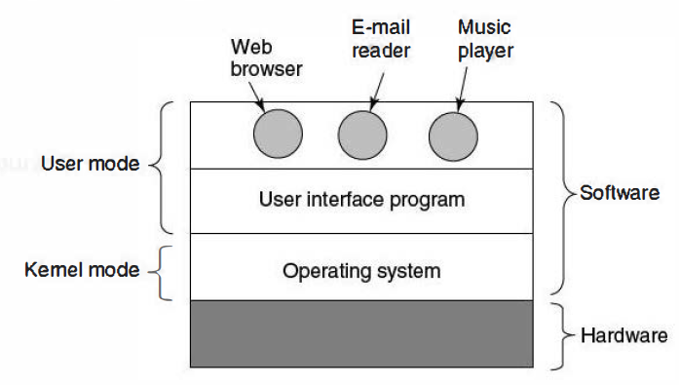
The hardware consists of chips, boards, disks, a keyboard, a monitor, and similar physical objects. On top of the hardware is the software. Most computers have two modes of operation:
- kernel mode
- User mode.
The user interface program, shell or GUI, is the lowest level of user-mode software, and allows the user to start other programs, such as a Web browser, email reader, or music player.
An important distinction between the operating system and normal (user mode) software is that if a user does not like a particular e-mail reader, he is free to get a different one or write his own if he so chooses; he is not free to write his own clock interrupt handler, which is part of the operating system and is protected by hardware against attempts by users to modify it.
The architecture (instruction set, memory organization, I/O, and bus structure) of most computers at the machine language level is primitive and awkward to program, especially for input/output.
Without an operating system you would not be able to use your computer. Turning on a computer loads the operating system into computer hardware, which then loads and centrally controls all other application software in the background. At this point the user is free to interact with applications, perhaps by typing on the keyboard or clicking a mouse. The operating system then uses computer hardware to carry out the requests. For operating system to carry out this, it must contain appropriate device driver software for every hardware device in the computer. Each device driver tells the operating system how to use that device.
Booting the Computer
Every Pentium contains a parent board (formerly called a motherboard). On the parent board is a program called the system BIOS (Basic Input Output System). The BIOS contains low-level I/O software, including procedures to read the keyboard, write to the screen, and do disk I/O, among other things. Nowadays, it is held in a flash RAM, which is non-volatile but which can be updated by the operating system when bugs are found in the BIOS.
When the computer is booted, the BIOS is started. It first checks to see how much RAM is installed and whether the keyboard and other basic devices are installed and responding correctly. It starts out by scanning the ISA and PCI buses to detect all the devices attached to them. Some of these devices are typically legacy (i.e., designed before plug and play was invented) and have fixed interrupt levels and 110 addresses (possibly set by switches or jumpers on the 110 card, but not modifiable by the operating system). These devices are recorded. The plug and play devices are also recorded. If the devices present are different from when the system was last booted, the new devices are configured.
The BIOS then determines the boot device by trying a list of devices stored in the CMOS memory. The user can change this list by entering a BIOS configuration program just after booting. Typically, an attempt is made to boot from the floppy disk, if one is present.
Process Management
A key concept in all operating systems is the process. A process is a program in execution or a process is defined as an entity which represents the basic unit of work to be implemented in the system and a program that is loaded into memory and is executing is commonly referred to as a process.
Associated with each process is its address space, a list of memory locations from 0 to some maximum, which the process can read and write.
The address space contains the executable program, the program's data, and its stack. Also associated with each process is a set of resources, commonly including registers (including the program counter and stack pointer), a list of open files, outstanding alarms, lists of related processes, and all the other information needed to run the program.
In many operating systems, all the information about each process, other than the contents of its own address space, is stored in an operating system table called the process table, which is an array (or linked list) of structures, one for each process currently in existence.
The key process management system calls are those dealing with the creation and termination of processes. Consider a typical example. A process called the command interpreter or shell reads commands from a terminal. The user has just typed a command requesting that a program be compiled. The shell must now create a new process that will run the compiler. When that process has finished the compilation, it executes a system call to terminate itself.
If a process can create one or more other processes (referred to as child processes) and these processes in turn can create child processes, we quickly arrive at the process tree structure of. Related processes that are cooperating to get some job done often need to communicate with one another and synchronize their activities. This communication is called inter-process communication.
Components of a process
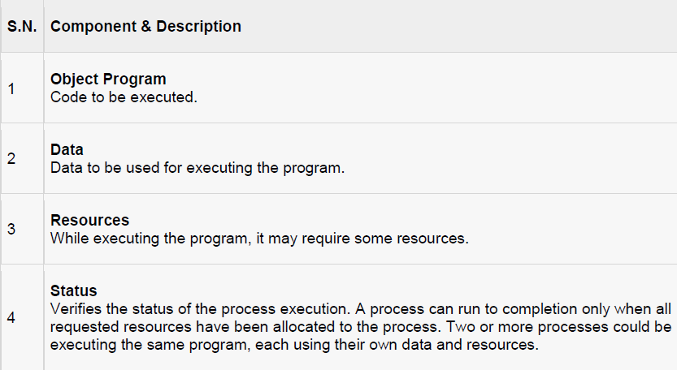
Program vs Process
A program by itself is not a process. It is a static entity made up of program statement while process is a dynamic entity. Program contains the instructions to be executed by processor.
A program takes a space at single place in main memory and continues to stay there. A program does not perform any action by itself.
Process States
As a process executes, it changes state. The state of a process is defined as the current activity of the process. Process can have one of the following five states at a time.
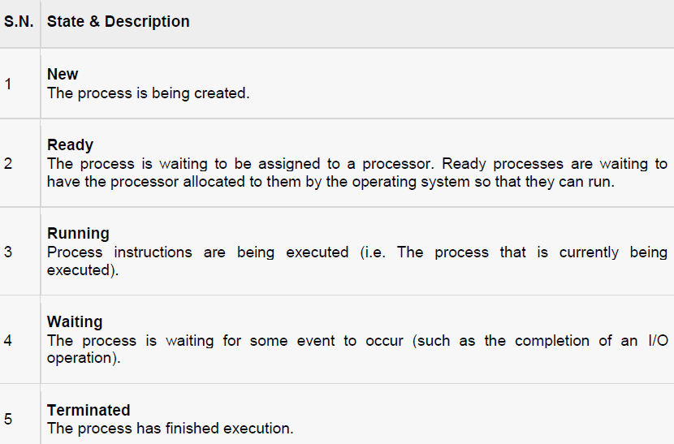
- Ready: The process is in main memory and available for execution.
- Blocked: The process is in main memory and awaiting an event.
- Blocked/Suspend: The process is in secondary memory and awaiting an event.
- Ready/Suspend: The process is in secondary memory but is available for execution as soon as it is loaded into main memory.
Suspended Processes
Characteristics of suspend process
1. Suspended process is not immediately available for execution.
2. The process may or may not be waiting on an event.
3. For preventing the execution, process is suspend by OS, parent process, process itself and an agent.
4. Process may not be removed from the suspended state until the agent orders the removal.
Swapping is used to move all of a process from main memory to disk. When all the process by putting it in the suspended state and transferring it to disk.
Reasons for process suspension
- Swapping: OS needs to release required main memory to bring in a process that is ready to execute.
- Timing: Process may be suspended while waiting for the next time interval.
- Interactive user request: Process may be suspended for debugging purpose by user.
- Parent process request: To modify the suspended process or to coordinate the activity of various descendants.
Process Control Block, PCB
Whenever processes changes state, the operating system reacts by placing the process PCB in the list that corresponds to its new state. Only one process can be running on any processor at any instant and many processes may be ready and waiting state.
Each process is represented in the operating system by a process control block (PCB) also called a task control block. PCB is the data structure used by the operating system. Operating system groups all information that needs about particular process.
PCB contains many pieces of information associated with a specific process which is described below.
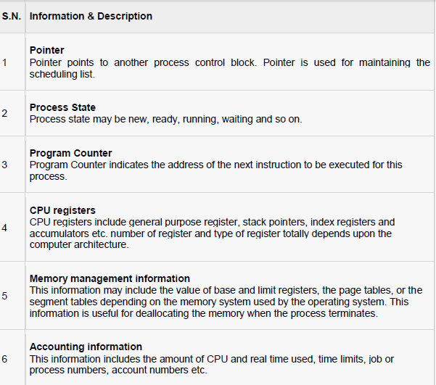
Process control block includes CPU scheduling, I/O resource management, file management information etc. The PCB serves as the repository for any information which can vary from process to process. Loader/linker sets flags and registers when a process is created. If that process gets suspended, the contents of the registers are saved on a stack and the pointer to the particular stack frame is stored in the PCB. By this technique, the hardware state can be restored so that the process can be scheduled to run again.
Thread vs. Process
    - A thread is a dispatch able unit of work (lightweight process) that has independent context, state and stack
    - A process is a collection of one or more threads and associated system resources
    - Traditional operating systems are single-threaded systems and Modern operating systems are multithreaded systems
    - Multithreading is a technique in which a process, executing an application, is divided into threads that can run concurrently
      - Handling several independent tasks of an application that do not need to be serialized (e.g. database servers, web servers)
    - Each thread has independent context, state and stack
    - All threads share the same address space and a separate thread table is needed to manage the threads
    - Threads can be managed in the kernel or user space
      - Kernel Space
        - The operating system is aware of the existence of multiple threads
        - When a thread blocks, the operating system chooses the next one to run, either from the same process or a different one
        - The kernel has a thread table
        - Thread management is slow
      - User Space
        - The operating system is not aware of the existence of multiple threads
        - When a thread is about to block, it chooses and starts its successor before stopping (e.g. P-threads of POSIX, C-threads of Mach)
        - The user space has a thread table
        - Thread management is much faster (specially switching)
        - When one thread blocks, the kernel blocks the entire process
    - Both systems are in use and various hybrid schemes have been proposed as well
    - Introducing threads into an existing system needs a substantial system redesign.
Inter-Process Communication, Concurrency and Its Problems
A. Basic Concept
  - The most fundamental task of modern operating systems is management of multiple processes within uniprocessor, multiprocessor or distributed computer systems
  - The fundamental design issue in the management of multiple processes is concurrency: simultaneous execution of multiple processes
  - Concurrency arises in three different contexts
    - Multiple applications: concurrently running applications
    - Structured applications: an application structured as a set of concurrent processes (threads)
    - OS structure: OS implemented as a set of processes
B. Inter-process Communication
There is frequent interaction among concurrently running processes. There are three ways in which concurrent processes interact with each other:

Competition for Resources
    - It occurs when independent processes that are not intended to work together compete for the use of the same or shared resource, e.g. printer, memory, or file
    - There is no exchange of information between competing processes
    - Processes are unaware of each other

Cooperation by Sharing Resources
    - It occurs when processes that are not necessarily aware of each other use and update shared data without reference to other processes but know that other processes may have access to the same data
    - Processes must cooperate to ensure that the data they share are properly managed
    - Processes are aware of each other indirectly

Cooperation by Communication
    - It occurs when various processes communicate with each other, for instance with message passing in order to provide a way to synchronize or coordinate their various activities.
    - There is nothing shared between processes
    - Processes are aware of each other directly

C. Concurrency Problems
There are some serious problems associated with the interaction of concurrently running processes:

Race Condition
    - A situation that occurs when two or more processes are reading or writing into some shared data and the final result depends on who runs precisely when
E.g. Printer Spooler: when a process wants to print a file, it enters the file name in a special spooler directory.
- There are two globally shared variables
Outfile: points to the next file to be printed
Infile: points to the next free slot in the directory
There are some files in the spooler directory and assume the current value of infile is 7 and that of outfile is 3
Assume that simultaneously process A and process B decide they want to queue a file for printing
          - Process A reads infile and stores the value 7 in its local variable (x=infile)
          - An interrupt occurs and the CPU decides that process A has run long enough so it switches to process B
          - Process B reads infile and stores the value 7 in its local variable (y=infile)
          - Process B stores the name of its file in slot 7 and adjusts infile to be 8
          - Eventually process A runs again, it checks x and finds 7 there, and writes its file name in slot 7, erasing the name process B just put there, it updates infile to be 8
          - The printer daemon will now print the file of process A, process B file will never get any output

Deadlock
    - A set of blocked processes each holding a resource and waiting to acquire a resource held by another process in the set.
    - It is the permanent blocking of a set of processes that either compete for system resources or communicate with each other.
    - It refers to a situation in which a set of two or more processes are waiting for other members of the set to complete an operation in order to proceed, but none of the members is able to proceed.
    - E.g. Traffic deadlock: consider a situation in which four cars have arrived at a four-way stop intersection at the same time. The four quadrants of the intersection are the resources over which control is needed. If all four cars proceed into the intersection, then each car controls one resource (one quadrant) but cannot proceed because the required second resource has already been controlled by another car. Hence deadlock will occur. The main reason for this deadlock is because each car needs exclusive use of both resources for certain period of time
    - It is a difficult phenomenon to anticipate and there are no easy general solutions to this problem
Example
System has 2 tape drives.
P0 and P1 each hold one tape drive and each needs another one.
Example
● Semaphores A and B, initialized to 1
P0 P1"
Wait (A); wait (B)
Wait (B); wait (A)
Deadlock Characterization!
- Mutual exclusion: only one process at a time can use a resource.
- Hold and wait: a process holding at least one resource is waiting to acquire additional resources held by other processes.
- No pre-emption: a resource can be released only voluntarily by the process holding it, after that process has completed its task.
- Circular wait: there exists a set {P0, P1, …, P0} of waiting processes such that P0 is waiting for a resource that is held by P1, P1 is waiting for a resource that is held by P2, …, Pn–1 is waiting for a resource that is held by Pn, and P0 is waiting for a resource that is held by P0.
Deadlock Prevention!
- Mutual Exclusion – not required for sharable resources; must hold for non-sharable resources.
- Hold and Wait – must guarantee that whenever a process requests a resource, it does not hold any other resources."
- Require process to request and be allocated all its resources before it begins execution, or allow process to request resources only when the process has none.
- Low resource utilization; starvation possible."
- No Pre-emption
- If a process that is holding some resources requests another resource that cannot be immediately allocated to it, then all resources currently being held are released."
- Pre-empted resources are added to the list of resources for which the process is waiting."
- Process will be restarted only when it can regain its old resources, as well as the new ones that it is requesting.
- Circular Wait – impose a total ordering of all resource types, and require that each process requests resources in an increasing order of enumeration."

Starvation
    - It refers to the situation in which a process is ready to execute but is continuously denied access to a processor in deference to other processes.
E.g. suppose that there are three processes P1, P2, and P3 and each require periodic access to resource R. If the operating system grants the resource to P1 and P2 alternately, P3 may indefinitely be denied access to the resource, thus starvation may occur.
D. Mutual Exclusion
    - The key to preventing race condition is to enforce mutual exclusion: It is the ability to exclude (prohibit) all other processes from using a shared variable or file while one process is using it.
    - Part of a program where shared resource (critical resource) is accessed is called critical region or critical section
Process A Process B

- -
Non-Critical Section
- -
- -

Read infile Read infile
Critical Section
Put file Put file
Increment infile Increment infile

- -
Non-Critical Section
- -
- -
    - The fundamental strategy for implementing mutual exclusion is avoiding the situation where no two processes could ever be in their critical regions at the same time.
    - There are some basic requirements that should be met while implementing mutual exclusion
- No two processes may be simultaneously in their critical regions
- No assumptions may be made about speed or the number of processors
- No process running outside its critical region may block other processes
- No process should have to wait forever to enter its critical region

Processor Scheduling (CPU Scheduling)
Processes are managed through the use of multiple queues (or lists) of PCB's; the word queue (in an OS queue contains all jobs submitted to the system, but not yet in main memory the ready queue contains all jobs in main memory ready to execute. Each I/O device has a queue of jobs waiting for various I/O operations .A process is dispatched from the ready queue to the CPU; its processing may cause it to be put on a device queue
  - Processor Scheduling is the means by which operating systems allocate processor time for processes. It can be implemented on uniprocessor systems (Uniprocessor Scheduling), Multiprocessor systems (Multiprocessor Scheduling), Real-time systems (Real-time Scheduling)
  - The operating system makes three types of scheduling decisions with respect to execution of processes:
    - Long-term Scheduling
      - The decision to add to the pool of processes to be executed
      - It determines when new processes are admitted to the system
      - It is performed when a new process is created and admitted
        - New Ready
        - Blocked/Suspend Ready/Suspend
    - Medium-term Scheduling
      - The decision to add to the number of processes that are partially/fully in main memory
      - It determines when a program is brought partially or fully into main memory so that it may be executed
      - It is performed when swapping is done
        - Ready/Suspend Ready
        - Blocked/Suspend Blocked
    - Short-term Scheduling
      - The decision of which ready process to execute next
      - It determines which ready process will get processor time next
      - It is performed when a ready process is allocated the processor (when it is dispatched)
Ready Running
Part of the operating system that makes scheduling decision is called scheduler and the algorithm it uses is called scheduling algorithm.
In the case of short term scheduling, the module that gives control of CPU to the process selected by the scheduler is called dispatcher. Its functions are
    - Process switch (Context Switch)
    - Mode Switch: Kernel User
    - Control branching: to the proper location in the user program
There are some requirements that should be met by short-term schedulers/scheduling algorithms. Some of these requirements are user-oriented, which relate to the behavior of the system as perceived by the individual user or process and the rest are system-oriented, which focus on effective and efficient utilization of the processor
    - Response Time: The time from submission of request until the response begins to be received. it should be minimized
    - Turn Around Time: For batch users, the interval of time between the submission of a process and its completion should be minimized (Completion Time-Start Time)
    - Throughput: The number of processes completed per unit time (jobs / second). it should be maximized
    - Efficiency/CPU Utilization: The percentage of time that the CPU is busy should be maximized
    - Dispatch latency – time it takes for the dispatcher to stop one process and start another running.
    - Waiting time – sum of the periods spent waiting in the ready queue.
    - Service time -The time required by a device to handle a request. (seconds)
    - Queuing time -Time on a queue waiting for service from the device. (seconds)
    - Residence time- The time spent by a request at a device.
Residence time = service time + queuing time.
Generally to optimize the execution time
- Max throughput
- Min turnaround time
- Min waiting time
- Min response time
There are two main characteristics of short-term scheduling algorithms
- Selection function
- It determines which process, among ready processes, is selected for execution
- It may be based on
        - Priority
        - Resource requirement
        - Execution behavior: time spent in system so far (waiting and executing), total service time required by the process
          - Decision mode
- It specifies the instants in time at which the selection function is exercised
- There are two types of decision modes
- Preemptive
        - The strategy of allowing processes that are logically runnable to be temporarily suspended and be moved to the ready state.
        - Events that may result pre-emption are arrival of new processes, occurrence of an interrupt that moves blocked process to ready state and clock interrupt
        - Suitable for general purpose systems with multiple users
        - Guarantees acceptable response time and fairness
        - Context switching is an overhead
- Non-Preemptive
        - Run to completion method: once a process is in running state, it continues to execute until it terminates or blocks itself to wait for some event
        - Simple and easy to implement
        - Used in early batch systems
        - It may be well reasonable for some dedicated systems
        - Efficiency can be attained but response time is very high
- The CPU scheduler (short-term scheduler) selects from among the processes in memory that are ready to execute, and allocates the CPU to one of them.
- A ready queue may be implemented as a FIFO queue, priority queue, a tree, or an unordered linked list.
CPU scheduling decisions may take place when a process:
1. Switches from running to waiting state (ex., I/O request).
2. Switches from running to ready state (ex., Interrupts occur).
3. Switches from waiting to ready state (ex., Completion of I/O).
4. Terminates.
Scheduling under 1 and 4 is nonpreemptive; otherwise is called pre-emptive.
Under nonpreemptive scheduling, once the CPU has been allocated to a process, the process keeps the CPU until it releases the CPU either by terminating or by switching to the waiting state.

Scheduling Algorithms (Short-term Scheduling Algorithms)
CPU scheduling deals with the problem of choosing a process from the ready queue to be executed by the CPU.
• The following CPU scheduling algorithms will be described:
- First-Come, First-Served (FCFS).
- Shortest-Job-First (SJF).
- Priority.
- Round-Robin (RR).
- Multilevel Queue.
- Multilevel Feedback Queue.
- First-Come, First-Served (FCFS) Scheduling
- It is the simplest CPU scheduling algorithm.
- The process that requests the CPU first is allocated the CPU first.
- The average waiting time under FCFS is long.
Example 1
Process | Arrival Time | CPU Burst Time
P1 | 0 | 8
P2 | 1 | 4
P3 | 2 | 9
P4 | 3 | 5
Average wait (Residence Time at the CPU) = ((8-0) + (12-1) + (21-2) + (26-3))/4 = 61/4 = 15.25
Example 2:
Process | CPU Burst Time
P1 | 24
P2 | 3
P3 | 3
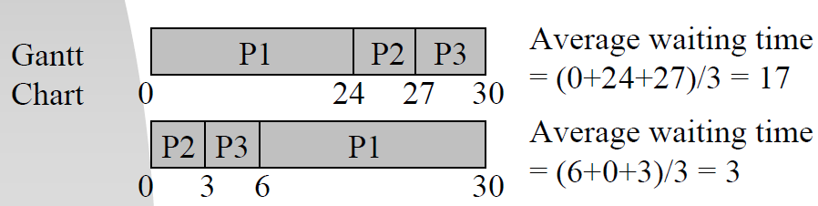
Average turnaround time = (24+27+30)/3=27
Throughput = 3/30= 1/10
Waiting time for P1 = 0; P2 = 24; P3 = 27 (milliseconds) [if processes arrive in the order P2, P3, P1.]
Average waiting time: (0 + 24 + 27) / 3 = 17 (milliseconds) [If the process arrive in the order of p1, p2, p3]
The average waiting time is highly affected by process CPU burst times!
N.B: The order of processes in FCFS queue is important.
Average response time = (0+24+27)/3 = 17

If they arrive in the order of P3, P2, P1
Process P3 P2 P1
Service Time (T_{s}) = 3 3 24
Turnaround time (T_{r}) 3 6 30
Response time 0 3 6
T_{r}/T_{s} 1 2 1.25
Average response time = (0+3+6)/3 = 3
Average turnaround time = (3+6+30)/3=13
Throughput = 3/30= 1/10
Assignment: Write the advantages and disadvantages of FCFS algorithm.
- Shortest Job First Scheduling (SJFS)
- Process with the shortest expected processing time (CPU burst) is selected next
- Its selection function is execution time and it uses non preemptive scheduling/decision mode
- Optimal for minimizing queuing time, but impossible to implement and it tries to predict the process to schedule based on previous history.
- Associate with each process the length of its next CPU burst. Use these lengths to schedule the process with the shortest time.
- Two schemes:
- Non pre- emptive – once CPU given to the process it cannot be preempted until completes its CPU burst.
- Preemptive – if a new process arrives with CPU burst length less than remaining time of current executing process, preempt. This scheme is known as the Shortest-Remaining-Time-First (SRTF).
- SJF is optimal – gives minimum average waiting time for a given set of processes.

Example 1:
Process | Arrival Time | CPU Burst Time
P1 | 0 | 8
P2 | 1 | 4
P3 | 2 | 9
P4 | 3 | 5
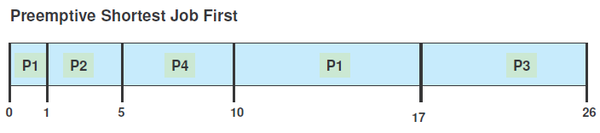
Average wait = ((5-1) + (10-3) + (17-0) + (26-2))/4 = 52/4 = 13.0
Example2:
Process | CPU Burst Time
P1 | 6
P2 | 8
P3 | 7
P4 | 3
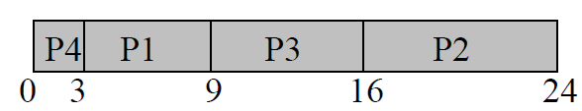
Average waiting time= (3+16+9+0)/4 = 7
Example 3:
Process | CPU Burst Time
P1 | 24
P2 | 3
P3 | 3

Process P3 P2 P1
Turnaround time 3 6 30
Response time 0 3 6
Average response time = (0+3+6)/3 = 3
Average turnaround time = (3+6+30)/3=13
Throughput = 3/30

Associate with each process the length of its next CPU burst. Use these lengths to schedule the process with the shortest time.
There are two schemes:
- Non pre-emptive – once CPU given to the process it cannot be pre-empted until completes its CPU burst.
- Pre-emptive – if a new process arrives with CPU burst length less than remaining time of current executing process, pre-empt. This scheme is known as the Shortest-Remaining-Time-First (SRTF).
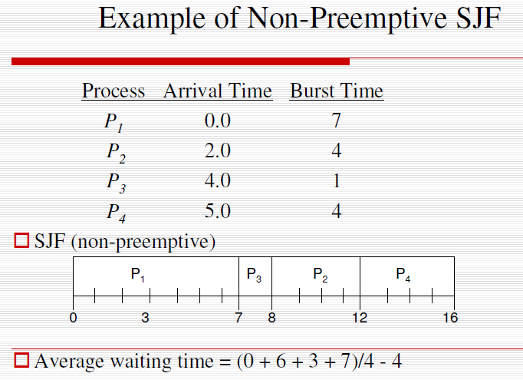
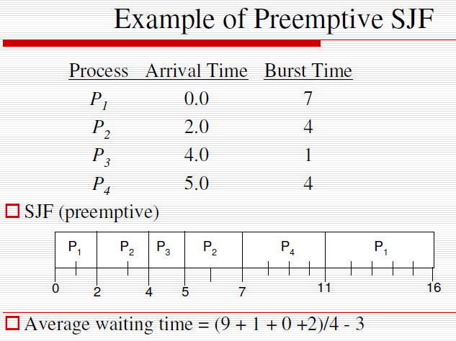
- Priority Scheduling
- Assign each process a priority. Schedule highest priority first. All processes within same priority are FCFS.
- Priority may be determined by user or by some default mechanism. The system may determine the priority based on memory requirements, time limits, or other resource usage.
- Starvation occurs if a low priority process never runs. Solution: build aging into a variable priority (as time progresses increase the priority of the process).
- A priority number (integer) is associated with each process
- The CPU is allocated to the process with the highest priority (smallest integer ≡ highest priority).
Priority may be:
1. Pre-emptive: CPU scheduling is invoked whenever a process arrives at the ready queue, or the running process relinquishes the CPU.
2. Nonpreemptive: CPU scheduling is invoked only when the running process relinquishes the CPU.
- SJF is a priority scheduling where priority is the predicted next CPU burst time.
Example:
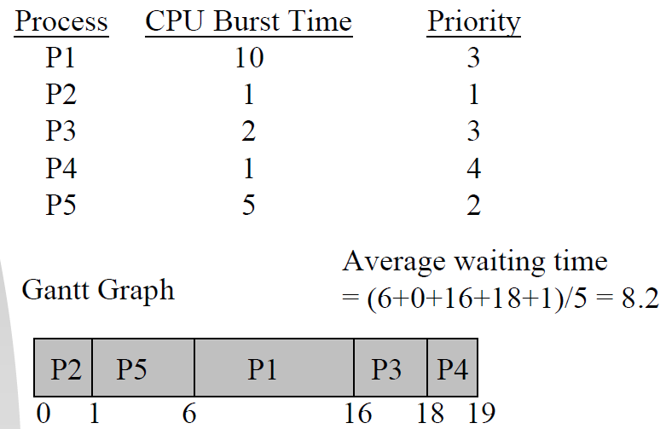
Major Problem
- Indefinite Blocking (/Starvation)
- Low-priority processes could starve to death!
A Solution: Aging
- Round-Robin Scheduling (RR)
RR is similar to FCFS except that pre-emption is added to switch between processes and designed for time sharing systems.
• Each process gets a small unit of CPU time (time quantum or time slice), usually 10-100 milliseconds. After this time has elapsed, the process is pre-empted and added to the end of the ready queue.
That is, after the time slice is expired an interrupt will occur and a context switch.
Choosing a time quantum
– Too short - inordinate fraction of the time is spent in context switches.
– Too long - reschedule latency is too great. If many processes want the CPU, then it's a long time before a particular process can get the
CPU. This then acts like FCFS.
– Adjust so most processes won't use their slice. As processors have become faster, this is less of an issue.
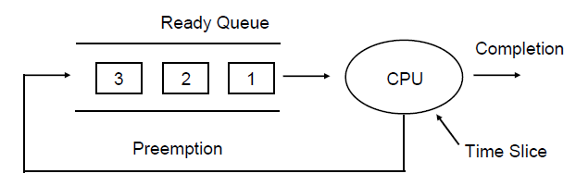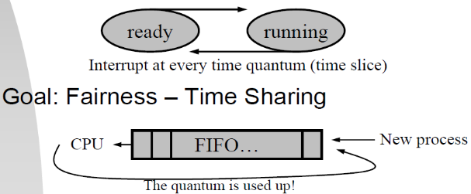
Example
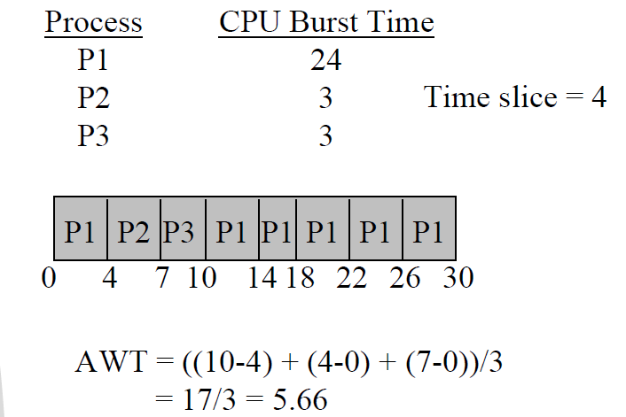
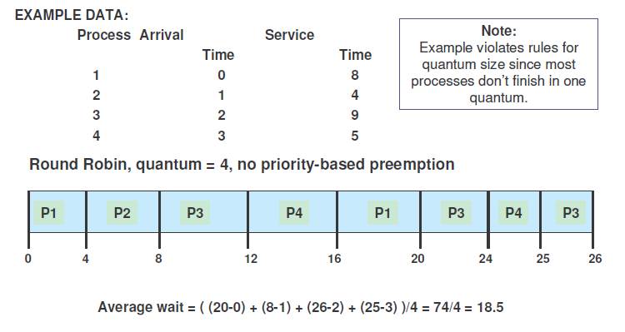
- Multilevel Queue Scheduling
Partition the ready queue into several separate queues =>Processes can be classified into different groups and permanently assigned to one queue.
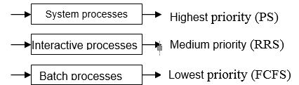
Could also use a time slice algorithm where each queue gets a certain amount of CPU time, which it can schedule among its processes.
20% ---FCFSS

50% ---PS
Batch processes

Interactive processes

System processes
30% ---RRS

- Intra-queue scheduling
- Independent choice of scheduling algorithms.
- Inter-queue scheduling
- Fixed-priority pre-emptive scheduling
e.g., foreground queues always have absolute priority over the background queues.
- Time slice between queues
e.g., 80% CPU is given to foreground processes, and 20% CPU to background processes.
- It is used for situations for which processes can be classified into different groups
    - System processes
    - Interactive processes
    - Batch processes
- The ready queue is partitioned into several separate queues
- Each processes is assigned to one queue permanently, based on some property of the process such as memory size, process priority, process type etc.
- Each queue has its own scheduling algorithm: RRS, FCFSS, SJFS, PS etc
    - System processes…………… PS
    - Interactive processes…………RRS
    - Batch processes………………FCFSS
- There must be some kind of scheduling between the queues
    - Commonly implemented as fixed-priority preemptive scheduling, i.e. system processes have absolute priority over the interactive processes and interactive processes have absolute priority over the batch processes. Lowest priority processes may be starved.

- Multilevel Feedback Queue
A process can move between various queues; aging can be implemented this way.
• If a process waits too long in a lower-priority queue may be moved to a higher-priority queue (this form of aging to prevent starvation).
• If a process uses too much CPU time, it will be moved to lower-priority queues. This leaves I/O bound and interactive processes in the higher-priority queues.
• In general, the multilevel feedback queue scheduling algorithm is the most complex.
Idea: Separate processes with different CPU-burst characteristics!
Example
Three queues:
– Q0 – time quantum 8 milliseconds
– Q1 – time quantum 16 milliseconds
– Q2 – FCFS
• Scheduling: – A new job enters queue Q0 which is served FCFS.
When it gains CPU, job receives 8 milliseconds. If it does not finish in 8 milliseconds, job is moved to queue Q1.
– At Q1 job is again served FCFS and receives 16 additional milliseconds. If it still does not complete, it is pre-empted and moved to queue Q2.
• The Multilevel Feedback Queue Scheduling is pre-emptive.
Multiple-Processor Scheduling
- CPU scheduling in a system with multiple CPUs
- A Homogeneous System
- Processes are identical in terms of their functionality.
- Can processes run on any processor?
- A Heterogeneous System
- Programs must be compiled for instructions on proper processors.
- Load Sharing – Load Balancing!!
- A queue for each processor
- Self-Scheduling – Symmetric Multiprocessing
- A common ready queue for all processors.
- Self-Scheduling
- Need synchronization to access common data structure, e.g., queues.

Chapter Three

Memory Management
Memory is a large array of words or bytes, each with its own address in computer system.
A program resides on a disk as a binary executable file. The program must be brought into memory and placed within a process for it to be executed depending on the memory management in use the process may be moved between disk and memory during its execution. The collection of processes on the disk that are waiting to be brought into memory for execution forms the input queue; i.e. selected one of the process in the input queue and to load that process into memory.
- Memory management is the functionality of an operating system which handles or manages primary memory.
- Memory management keeps track of each and every memory location either it is allocated to some process or it is free.
- It checks how much memory is to be allocated to processes. It decides which process will get memory at what time.
- It tracks whenever some memory gets freed or unallocated and correspondingly it updates the status. The part of the operating system that manages (part of) the memory hierarchy is called the memory manager (task manager). Its job is to efficiently manage memory: keep track of which parts of memory are in use, allocate memory to processes when they need it, and deallocate it when they are done.
Memory management provides protection by using two registers, a base register and a limit register. The base register holds the smallest legal physical memory address and the limit register specifies the size of the range. For example, if the base register holds 300000 and the limit register is 120000, then the program can legally access all addresses from 300000 through 411999.
Instructions and data to memory addresses can be done in following ways
- Compile time -- When it is known at compile time where the process will reside, compile time binding is used to generate the absolute code.
- Load time -- When it is not known at compile time where the process will reside in memory, then the compiler generates re-locatable code.
- Execution time -- If the process can be moved during its execution from one memory segment to another, then binding must be delayed to be done at run time
- Dynamic Loading
In dynamic loading, a routine of a program is not loaded until it is called by the program. All routines are kept on disk in a re-locatable load format. The main program is loaded into memory and is executed. Other routines methods or modules are loaded on request. Dynamic loading makes better memory space utilization and unused routines are never loaded.
- Dynamic Linking
Linking is the process of collecting and combining various modules of code and data into a executable file that can be loaded into memory and executed. Operating system can link system level libraries to a program. When it combines the libraries at load time, the linking is called static linking and when this linking is done at the time of execution, it is called as dynamic linking.
In static linking, libraries linked at compile time, so program code size becomes bigger whereas in dynamic linking libraries linked at execution time so program code size remains smaller.
Logical versus Physical Address Space
An address generated by the CPU is a logical address whereas address actually available on memory unit is a physical address. Logical address is also known a Virtual address.
Virtual and physical addresses are the same in compile-time and load-time address-binding schemes; differ in execution-time address-binding scheme.
The set of all logical addresses generated by a program is referred to as a logical address space. The set of all physical addresses corresponding to these logical addresses is referred to as a physical address space.
The run-time mapping from virtual to physical address is done by the memory management unit (MMU) which is a hardware device. MMU uses following mechanism to convert virtual address to physical address. The base register is called a relocation register. The value in the relocation register is added to every address generated by a user process at the time it is sent to memory.

Swapping
Swapping is a mechanism in which a process can be swapped temporarily out of main memory to a backing store, and then brought back into memory for continued execution.
Backing store is a usually a hard disk drive or any other secondary storage which fast in access and large enough to accommodate copies of all memory images for all users.
If the physical memory of the computer is large enough to hold all the processes, the schemes described so far will more or less do. But in practice, the total amount of RAM needed by all the processes is often much more than can fit in memory.
Assume a multiprogramming environment with a round robin CPU-scheduling algorithm. When a quantum expires, the memory manager will start to swap out the process that just finished, and to swap in another process to the memory space that has been freed. When each process finishes its quantum, it will be swapped with another process.
Idle processes are mostly stored on disk, so they do not take up any memory when they are not running (although some of them wake up periodically to do their work, then go to sleep again). The other strategy, called virtual memory, allows programs to run even when they are only partially in main memory.

Memory Allocation (Contiguous Allocation)
The main memory must accommodate both the operating system and the various user processes. The memory is usually divided into two partitions, one for the resident operating system, and one for the user processes.
Main memory usually has two partitions
- Low Memory -- Operating system resides in this memory.
- High Memory --User processes then held in high memory.

Operating system uses the following memory allocation mechanism.
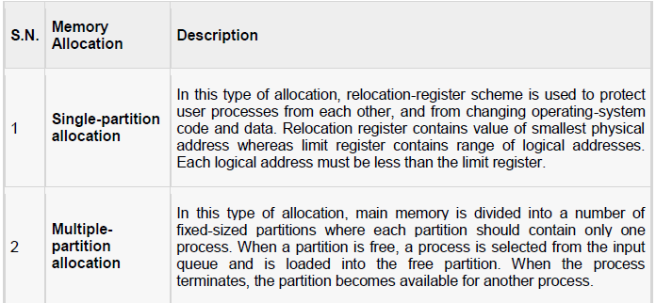
Memory allocation is done using Round-Robin Sequence. When a process arrives and needs memory, we search this set for a hole that is large enough for this process. If the hole is too large, it is split into two: One part is allocated to the arriving process; the other is returned to the set of holes. When a process terminates, it releases its block of memory, which is then placed back in the set of holes. If the new hole is adjacent to other holes, we merge these adjacent holes to form one larger hole.
This procedure is a particular instance of the general dynamic storage-allocation problem, which is how to satisfy a request of size n from a list of free holes. There are many solutions to this problem. The set of holes is searched to determine which hole is best to allocate, first-fit, best-fit, and worst-fit are the most common strategies used to select a free hole from the set of available holes.
First-fit: Allocate the first hole that is big enough. Searching can start either at the beginning of the set of holes or where the previous first-fit search ended. We can stop searching as soon as we find a free hole that is large enough.
Best-fit: Allocate the smallest hole that is big enough. We must search the entire list, unless the list is kept ordered by size. This strategy-produces the smallest leftover hole.
Worst-fit: Allocate the largest hole. Again, we must search the entire list unless it is sorted by size. This strategy produces the largest leftover hole which may be more useful than the smaller leftover hole from a best-t approach.
Fragmentation
As processes are loaded and removed from memory, the free memory space is broken into little pieces. It happens after sometimes that processes cannot be allocated to memory blocks considering their small size and memory blocks remains unused. This problem is known as Fragmentation.
Fragmentation is of two types
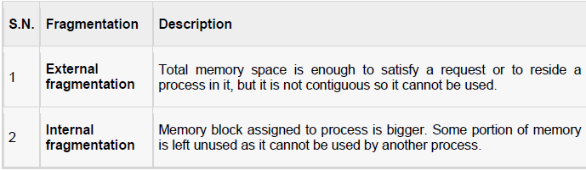
External fragmentation can be reduced by compaction or shuffle memory contents to place all free memory together in one large block.
Paging
External fragmentation is avoided by using paging technique. Paging is a technique in which physical memory is broken into blocks of the same size called pages (size is power of 2, between 512 bytes and 8192 bytes). When a process is to be executed, its corresponding pages are loaded into any available memory frames.
Logical address space of a process can be non-contiguous and a process is allocated physical memory whenever the free memory frame is available. Operating system keeps track of all free frames. Operating system needs n free frames to run a program of size n pages.
Address generated by CPU is divided into
- Page number (p) -- page number is used as an index into a page table which contains base address of each page in physical memory.
- Page offset (d) -- page offset is combined with base address to define the physical memory address.
Following figure show the paging table architecture.
Segmentation
Segmentation is a technique to break memory into logical pieces where each piece represents a group of related information. For example, data segments or code segment for each process, data segment for operating system and so on. Segmentation can be implemented using or without using paging.
Segmentation eliminates internal fragmentation but, like dynamic partitioning, it suffers from external fragmentation.
Unlike paging, segment is having varying sizes and thus eliminates internal fragmentation. External fragmentation still exists but to lesser extent.
Address generated by CPU is divided into
- Segment number (s) -- segment number is used as an index into a segment table which contains base address of each segment in physical memory and a limit of segment.
- Segment offset (o) -- segment offset is first checked against limit and then is combined with base address to define the physical memory address.

VIRTUAL MEMORY
Virtual memory is a technique that allows the execution of process that may not be completely in memory. The main visible advantage of this scheme is that programs can be larger than physical memory.
Virtual memory is the separation of user logical memory from physical memory this separation allows an extremely large virtual memory to be provided for programmers when only a smaller physical memory is available
Demand Paging
When a process is to be swapped in, the pager guesses which pages will be used before the process is swapped out again Instead of swapping in a whole process, the pager brings only those necessary pages into memory. Thus, it avoids reading into memory pages that will not be used in anyway, decreasing the swap time and the amount of physical memory needed.
Hardware support is required to distinguish between those pages that are in memory and those pages that are on the disk using the valid-invalid bit scheme. Where valid and invalid pages can be checked checking the bit and marking a page will have no effect if the process never attempts to access the pages. While the process executes and accesses pages that are memory resident, execution proceeds normally.

Access to a page marked invalid causes a page-fault trap.
This trap is the result of the operating system's failure to bring the desired page into memory. But page fault can be handled as following.
Steps in handling a page fault
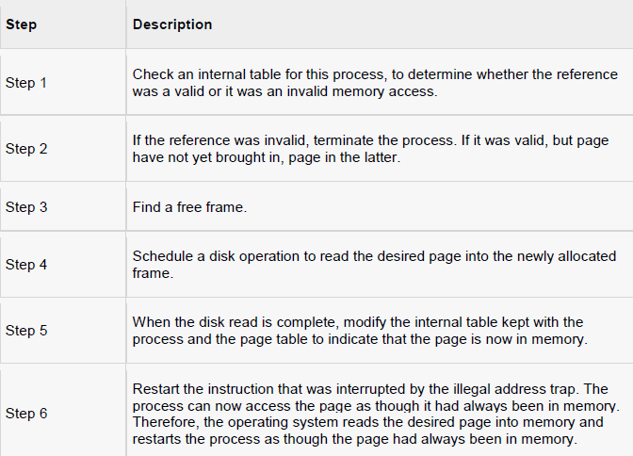
Advantages of Demand Paging:
- Large virtual memory.
- More efficient use of memory.
- Unconstrained multiprogramming. There is no limit on degree of multiprogramming.
Disadvantages of Demand Paging:
- Number of tables and amount of processor over head for handling page interrupts are greater than in the case of the simple paged management techniques.
- Due to the lack of an explicit constraints on a jobs address space size.
Page Replacement Algorithm
Page replacement algorithms are the techniques using which Operating System decides which memory pages to swap out, write to disk when a page of memory needs to be allocated.
When the page that was selected for replacement and was paged out, is referenced again then it has to read in from disk, and this requires for I/O completion. This process determines the quality of the page replacement algorithm: the lesser the time waiting for page-ins, the better is the algorithm. A page replacement algorithm looks at the limited information about accessing the pages provided by hardware, and tries to select which pages should be replaced to minimize the total number of page misses, while balancing it with the costs of primary storage and processor time of the algorithm itself.
First in First out (FIFO) algorithm
- Oldest page in main memory is the one which will be selected for replacement.
- Easy to implement, keep a list, replace pages from the tail and add new pages at the head.

~~~END OF THE CHAPTER~~~

Chapter 4

IO Management
  - I/O HARDWARE
Computers operate on many kinds of devices. General types include storage devices (disks, tapes), transmission devices (network cards, modems), and human-interface devices (screen, keyboard, mouse). A device communicates with a computer system by sending signals over a cable or even through the air.
The device communicates with the machine via a connection point termed a port (for example, a serial port). If one or more devices use a common set of wires, the connection is called a bus. In other terms, a bus is a set of wires and a rigidly defined protocol that specifies a set of messages that can be sent on the wires.
Controller
A controller is a collection of electronics that can operate a port, a bus, or a device. A serial-port controller is an example of a simple device controller. This is a single chip in the computer that controls the signals on the wires of a serial port.
The SCSI bus controller is often implemented as a separate circuit board (a host adapter) that plugs into the computer. It contains a processor, microcode, and some private memory to enable it to process the SCSI protocol messages. Some devices have their own built-in controllers.
I/O port
An I/O port typically consists of four registers, called the status, control, data-in, and data-out registers.
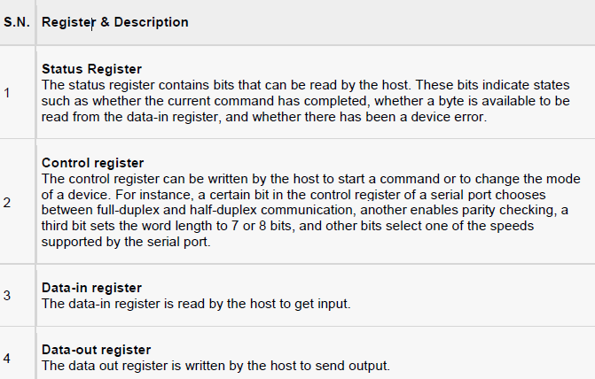
I/O devices
I/O Devices can be categorized into following category.
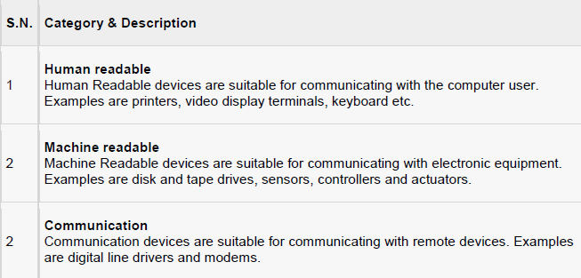
Following are the differences between I/O Devices
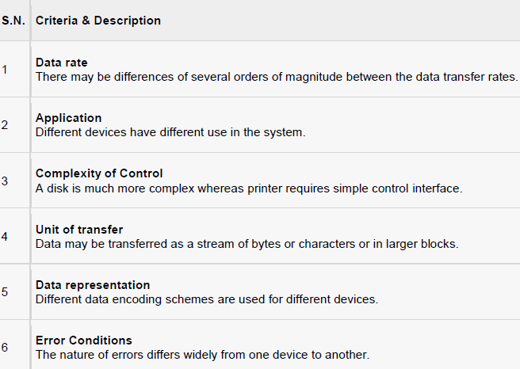
Direct Memory Access (DMA)
Many computers avoid burdening the main CPU with programmed I/O by offloading some of this work to a special purpose processor. This type of processor is called, a Direct Memory Access (DMA) controller. A special control unit is used to transfer block of data directly between an external device and the main memory, without intervention by the processor. DMA is particularly useful on devices like disks, where many bytes of information can be transferred in single I/O operations. When used with an interrupt, the CPU is notified only after the entire block of data has been transferred. For each byte or word transferred, it must provide the memory address and all the bus signals controlling the data transfer. Interaction with a device controller is managed through a device driver.
Handshaking is a process between the DMA controller and the device controller. It is performed via wires using terms DMA request and DMA acknowledge.
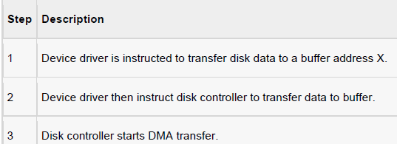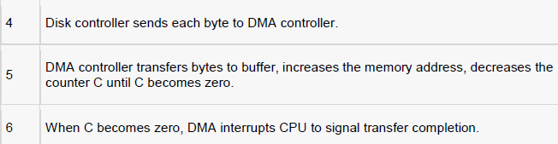
Device Controllers
A computer system contains a many types of I/O devices and their respective controllers
- network card
- graphics adapter
- disk controller
- DVD-ROM controller
- serial port
- USB
- sound card

SECONDARY STORAGE MANAGEMENT

Disk provide bulk of secondary storage of computer system. The disk can be considered the one I/O device that is common to each and every computer. Disks come in many size and speeds, and information may be stored optically or magnetically. Magnetic tape was used as an early secondary storage medium, but the access time is much slower than for disks. For backup, tapes are currently used.
Disk Performance Parameters
Seek time: Seek time is the time required to move the disk arm to the required track. It turns out that this is a difficult quantity to pin down. The seek time consists of two key components: the initial startup time and the time taken to traverse the tracks that have to be crossed once the access arm is up to speed.
Rotational delay: Time required to reach the desired sector by read or write head.
Transfer time: The transfer time to or from the disk depends on the rotation speed of the disk in the following fashion:
T= b/rN where T = transfer time, b = number of bytes to be transferred, N = number of bytes on a track
r = rotation speed, in revolutions per second
Disk Scheduling
If a device or controller is busy, any new requests for service will be placed on the queue of pending requests for that drive. When one request is completed, the operating system chooses which pending request to service next.
Different types of scheduling algorithms are as follows.
        - First Come, First Served scheduling algorithm (FCFS).
        - Shortest Seek Time First (SSTF) algorithm
        - SCAN algorithm
        - Circular SCAN (C-SCAN) algorithm
        - Look Scheduling Algorithm
Disk Management
Operating system is responsible for disk management. Following are some activities discussed.
Disk Formatting
Disk formatting is of two types.
- Physical formatting or low level formatting.
- Logical Formatting
- Physical Formatting
Disk must be formatted before storing data. Disk must be divided into sectors that the disk controllers can read/write. Low level formatting files the disk with a special data structure for each sector.
Data structure consists of three fields: header, data area and trailer. Header and trailer contain information used by the disk controller. Sector number and Error Correcting Codes (ECC) contained in the header and trailer. For writing data to the sector – ECC is updated.
For reading data from the sector – ECC is recalculated. Low level formatting is done at factory.
- Logical Formatting
After disk is partitioned, logical formatting is used. Operating system stores the initial file system data structures onto the disk.
Boot Block
When a computer system is powered up or rebooted, a program in read only memory executes. Diagnostic check is done first. Stage 0 boot program is executed. Boot program reads the first sector from the boot device and contains a stage-1 boot program.
May be boot sector will not contain a boot program. PC booting from hard disk, the boot sector also contains a partition table.
The code in the boot ROM instructs the disk controller to read the boot blocks into memory and then starts executing that code.
Full boot strap program is more sophisticated than the bootstrap loader in the boot ROM.
  - I/O Software
The CPU hardware uses an interrupt request line wire which helps CPU to sense after executing every instruction. When the CPU checks that a controller has put a signal on the interrupt request line, the CPU saves a state, such as the current value of the instruction pointer, and jumps to the interrupt handler routine at a fixed address. The interrupt handler part determines the cause of the interrupt performs the necessary processing and executes an interrupt instruction to return the CPU to its execution state.
The basic mechanism of interrupt enables the CPU to respond to an asynchronous event, such as when a device controller becomes ready for service. Most CPUs have two interrupt request lines.
- non-maskable interrupt - Such kind of interrupts are reserved for events like unrecoverable memory errors.
- maskable interrupt - Such interrupts can be switched off by the CPU before the execution of critical instructions that must not be interrupted.
Application I/O Interface
Application I/O Interface represents the structuring techniques and interfaces for the operating system to enable I/O devices to be treated in a standard, uniform way.
Following are the characteristics of I/O interfaces with respected to devices.
- Character-stream / block - A character-stream device transfers bytes in one by one fashion, whereas a block device transfers a complete unit of bytes.
- Sequential / random-access - A sequential device transfers data in a fixed order determined by the device, random-access device can be instructed to seek position to any of the available data storage locations.
- Synchronous / asynchronous - A synchronous device performs data transfers with known response time where as an asynchronous device shows irregular or unpredictable response time.
- Sharable / dedicated - A sharable device can be used concurrently by several processes or threads but a dedicated device cannot be used.
- Speed of operation - Device speeds may range from a few bytes per second to a few gigabytes p/s.
- Read-write, read only, or write only - Some devices perform both input and output, but others support only one data direction that is read only.
Clocks
Clocks are also called timers. The clock software takes the form of a device driver though a clock is neither a blocking device nor a character based device. The clock software is the clock driver. The exact function of the clock driver may vary depending on operating system. Generally, the functions of the clock driver include the following.
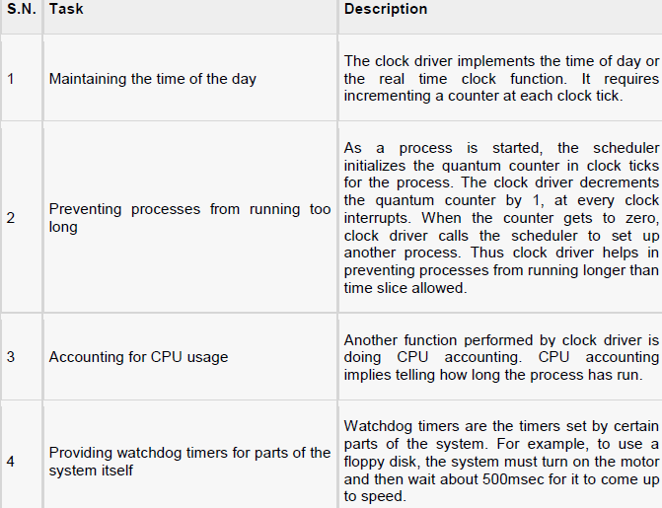
Kernel I/O Subsystem
Kernel I/O Subsystems responsible to provide many services related to I/O. Following are some of the services provided.
- Scheduling - Kernel schedules a set of I/O requests to determine a good order in which to execute them by Kernel I/O scheduler rearranges the order of the queue to improve the overall system efficiency and the average response time experienced by the applications.
- Buffering - Kernel I/O Subsystem maintains a memory area known as buffer that stores data while they are transferred between two devices.
- Caching - Kernel maintains cache memory which is region of fast memory that holds copies of data. Access to the cached copy is more efficient than access to the original.
- Spooling and Device Reservation - A spool is a buffer that holds output for a device, such as a printer, that cannot accept interleaved data streams
- Error Handling - An operating system that uses protected memory can guard against many kinds of hardware and application errors.
Device driver
Device driver is a program or routine developed for an I/O device. A device driver implements I/O operations or behaviors on a specific class of devices. The job of a device driver is following.
- To accept request from the device independent software above it.
- To see to it that the request is executed.

CHAPTER 5

File Management System
File
A file is a named collection of related information that is recorded on secondary storage such as magnetic disks, magnetic tapes and optical disks. In general, a file is a sequence of bits, bytes, lines or records whose meaning is defined by the files creator and user.
The physical storage is converted into logical storage by the operating system. The logical storage unit is said to be files called records. A record is a collection of related fields.
Operations of database files
Creating, Updating files, Reading files, writing files, Deleting, Opening, Closing, Appending, Seeking, Getting attributes, Setting Attributes and Renaming file.
File management system (FMS) is a collection of system soft wares programs that provides services to the users. The following are general objectives of FMS:
- To provide the IO support for multiuser
- Storages of data
- To optimize performance
File Structure
File structure is a structure, which is according to a required format that operating system can understand.
- A file has a certain defined structure according to its type.
- A text file is a sequence of characters organized into lines.
- A source file is a sequence of procedures and functions.
- An object file is a sequence of bytes organized into blocks that are understandable by the machine.
When operating system defines different file structures, it also contains the code to support these file structure.

File Attributes
File attributes vary from one operating system to another. The common attributes are,
Name – only information kept in human-readable form.
Identifier – unique tag (number) identifies file within file system
Type – needed for systems that support different types
Location – pointer to file location on device
Size – current file size
Protection – controls who can do reading, writing, executing
Time, date, and user identification – data for protection, security, and usage monitoring
Information about files are kept in the directory structure, which is maintained on the disk
File Type– Name, Extension
File type refers to the ability of the operating system to distinguish different types of file such as text files source files and binary files etc.
A common technique for implementing file types is to include the type as part of the file name. The name is split into two parts: a name and an extension. Following table gives the file type with usual extension and function.
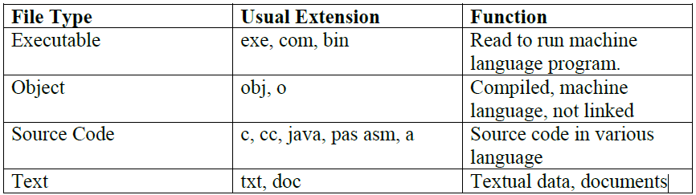
Many operating systems support many types of files. Operating system like MS-DOS and UNIX has the following types of files:
Ordinary files
- These are the files that contain user information.
- These may have text, databases or executable program.
- The user can apply various operations on such files like add, modify, delete or even remove the entire file.
Directory files
- These files contain list of file names and other information related to these files.
Special files:
- These files are also known as device files.
- These files represent physical device like disks, terminals, printers, networks, tape drive etc.
These special files are of two types
- Character special files - data is handled character by character as in case of terminals or printers.
- Block special files - data is handled in blocks as in the case of disks and tapes.
File Access Mechanisms
File access mechanism refers to the manner in which the records of a file may be accessed. There are several ways to access files
Sequential access
A sequential access is that in which the records are accessed in some sequence i.e. the information in the file is processed in order, one record after the other. This access method is the most primitive one. Example: Compilers usually access files in this fashion.
Direct/Random access
- Random access file organization provides, accessing the records directly.
- Each record has its own address on the file with by the help of which it can be directly accessed for reading or writing.
- The records need not be in any sequence within the file and they need not be in adjacent locations on the storage medium.
Indexed sequential access
- This mechanism is built up on base of sequential access.
- An index is created for each file which contains pointers to various blocks.
- Index is searched sequentially and its pointer is used to access the file directly.
Space Allocation
Files are allocated disk spaces by operating system. Operating systems deploy following three main ways to allocate disk space to files.
- Contiguous Allocation
- Each file occupies a contiguous address space on disk.
- Assigned disk address is in linear order.
- Easy to implement.
- External fragmentation is a major issue with this type of allocation technique.
- Linked Allocation
- Each file carries a list of links to disk blocks.
- Directory contains link / pointer to first block of a file.
- No external fragmentation
- Effectively used in sequential access file.
- Inefficient in case of direct access file.
- Indexed Allocation
- Provides solutions to problems of contiguous and linked allocation.
- An index block is created having all pointers to files.
- Each file has its own index block which stores the addresses of disk space occupied by the file.
- Directory contains the addresses of index blocks of files.
File System
Operating systems add a directory structure to break the partition up into smaller files, assign names to each file, and manage the free space available to create new files. The directory structure and methods for organizing a partition is called a File System. Different File Systems reflect different operating system requirements or different performance assumptions.
Each File System is described in detail in a separate section.
File Allocation Table (FAT)
It does not lose data because the computer crashed in the middle of an update and does not use a lot of memory. The directory is allocated at the start of the partition and it contains the table of free space. To write a new dataset, or to add data to an old one, the disk arm must be constantly moved between the location of the directory and the place where the data is being written. Without optimization, a file can end up fragmented into many small pieces.
When the system crashes, no data is lost. The CHKDSK (or on newer systems the SCANDISK) utility examines the FAT table to determine the status of every record on disk.
The FAT File system is used by DOS and is supported by all the other operating systems.
NTFS
NTFS provides everything. It supports long file names, large volumes, data security, and universal file sharing. Because the other operating systems cannot use it, NTFS is less attractive on personal desktop workstations or portables.

~~~END OF THE CHAPTER~~~

CHAPTER 6

Operating System Security
Security refers to providing a protection system to computer system resources such as CPU, memory, disk, software programs and most importantly data/information stored in the computer system. If a computer program is run by unauthorized user then he/she may cause severe damage to computer or data stored in it. So a computer system must be protected against unauthorized access, malicious access to system memory, viruses, worms etc.
The Security Problem
The operating system can allow users to protect their resources. We say that a system is secure if its resources art used and accessed as intended under all circumstances. Unfortunately, it is not generally possible to achieve total security. Security violations of the system can be categorized as being either intentional (malicious) or accidental. Among the forms of malicious access are the following:
We're going to discuss following topics in this chapter.
- Authentication
- One Time passwords
- Program Threats
- System Threats
- Computer Security Classifications
Authentication
Authentication refers to identifying the each user of the system and associating the executing programs with those users. It is the responsibility of the Operating System to create a protection system which ensures that a user who is running a particular program is authentic. Operating Systems generally identifies/authenticates users using following three ways:
- Username / Password - User need to enter a registered username and password with Operating system to login into the system.
- User card/key - User need to punch card in card slot, or enter key generated by key generator in option provided by operating system to login into the system.
- User attribute - fingerprint/ eye retina pattern/ signature - User need to pass his/her attribute via designated input device used by operating system to login into the system.
One Time passwords
One time passwords provides additional security along with normal authentication. In One-Time Password system, a unique password is required every time user tries to login into the system. Once a one-time password is used then it cannot be used again. One time password are implemented in various ways.
- Random numbers - Users are provided cards having numbers printed along with corresponding alphabets. System asks for numbers corresponding to a few alphabets randomly chosen.
- Secret key - User are provided a hardware device which can create a secret id mapped with user id. System asks for such secret id which is to be generated every time prior to login.
- Network password - Some commercial applications send one time password to user on registered mobile/ email which is required to be entered prior to login.
Program Threats
Operating system's processes and kernel do the designated task as instructed. If a user program made these process do malicious tasks then it is known as Program Threats. One of the common examples of program threat is a program installed in a computer which can store and send user credentials via network to some hacker. Following is the list of some well-known program threats.
- Trojan horse - Such program traps user login credentials and stores them to send to malicious user who can later on login to computer and can access system resources.
- Trap Door - If a program which is designed to work as required, have a security hole in its code and perform illegal action without knowledge of user then it is called to have a trap door.
- Logic Bomb - Logic bomb is a situation when a program misbehaves only when certain conditions met otherwise it works as a genuine program. It is harder to detect.
- Virus - Virus as name suggests can replicate them on computer system .They are highly dangerous and can modify/delete user files, crash systems. A virus is generally a small code embedded in a program. As user accesses the program, the virus starts getting embedded in other files/ programs and can make system unusable for user.
System Threats
System threats refer to misuse of system services and network connections to put user in trouble. System threats can be used to launch program threats on a complete network called as program attack. System threats create such an environment that operating system resources/ user files are mis-used. Following is the list of some well-known system threats.
- Worm -Worm is a process which can choke down a system performance by using system resources to extreme levels. A Worm process generates its multiple copies where each copy uses system resources, prevents all other processes to get required resources. Worm processes can even shut down an entire network.
- Port Scanning - Port scanning is a mechanism or means by which a hacker can detects system vulnerabilities to make an attack on the system.
- Denial of Service - Denial of service attacks normally prevents user to make legitimate use of the system. For example user may not be able to use internet if denial of service attacks browser's content settings.
Computer Security Classifications
As per the U.S. Department of Defense Trusted Computer System's Evaluation Criteria there are four security classifications in computer systems: A, B, C, and D. This is widely used specifications to determine and model the security of systems and of security solutions. Following is the brief description of each classification.
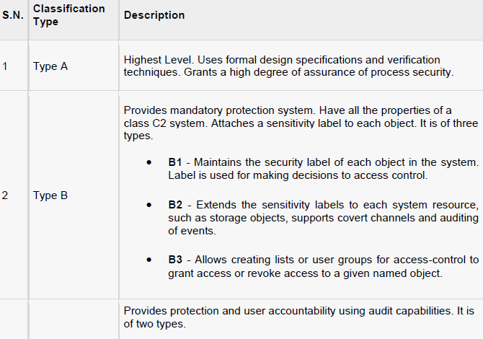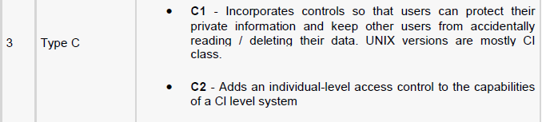

~~~END OF THE COURSE~~~

